Lesson 3: Wayback Machine

|  |  |  |  |
| --- | --- | --- | --- |
| **Name:** | **................................................................................................................** | **Class:** | **.............** |

## Time Travel Web Page Activity Instructions:

1. Open a new tab
2. Go to [web.archive.org](https://web.archive.org/) OR [this alternative](https://csinschools.io/web/wayback-alternative)



1. Type your school’s web address in the search box

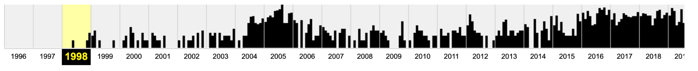

You will see a timeline of web page ‘captures’ for your chosen website. In this example, the first record of the website in wayback in 1998!

1. Click on the earliest entry

|  |  |
| --- | --- |
|  | * On the timeline, click on the earliest year the webpage has a history for * On the calendar, ‘mouse over’ the dates that have been shaded - this example has November 11, 1998 with a blue circle * Click on the ‘snapshot’ (18:42:25) * You should be able to see the first webpage   Note: sometimes error messages may come up. If this happens, choose the next ‘earliest’ date and try again. |

1. Take a screenshot of the ‘Oldest website record’ and insert the image into the table below
2. Fast Forward to current day (click your mouse on the timeline for 2022)
3. Take a screenshot of ‘Website today’ and insert the image into the table below

|  |  |  |
| --- | --- | --- |
| **Example:** | **Oldest website record** | **Website today** |
| Nintendo  Website:  <https://www.nintendo.com.au/>  **#WOW - checkout the difference!** |  |  |

## Time Travel Web Page Activity

|  |  |  |
| --- | --- | --- |
|  | **Oldest website record** | **Website today** |
| 1. Your School  Website: [type in address] |  |  |
| 2. Favourite Thing  Website: [type in address] |  |  |
| 3. Australian Government  <https://www.australia.gov.au/> |  |  |
| 4. The Great Barrier Reef  <https://greatbarrierreef.org/> |  |  |
| 5. Apple  [https://www.apple.com/](http://www.apple.com/) |  |  |
| 6. Adelaide Zoo  <https://www.adelaidezoo.com.au/> |  |  |
| 7. Uluru  <https://parksaustralia.gov.au/uluru/> |  |  |
| 8. Sydney Opera House  <https://www.sydneyoperahouse.com/> |  |  |
| 9. Rottnest Island  <https://www.rottnestisland.com/> |  |  |
| 10.Tasmanian Museum and Art Gallery  <https://www.tmag.tas.gov.au/> |  |  |

Share your answers with your class.